PROD Dev Regression Analysis:

Issue 1:

SELECT (SRC.VOLUME_OF_RECORDS_ALL),LKP.dimension_class,LKP.row_key,

COALESCE(LKP.row_key,CASE WHEN upper(SRC.VOLUME_OF_RECORDS_ALL) IS NULL THEN 0 ELSE -1 END),

TRGT.application_volume_of_records_all_c_key,Count(1) as CNT

FROM pandg_mdsdb.pg_mega_pgb_application_rita_final SRC

LEFT JOIN pandg_mdwdb.d_rita_application_c TRGT ON SRC.NAME=TRGT.row_id AND SRC.sourceinstance=TRGT.source_id

LEFT JOIN pandg_mdwdb.d_lov LKP ON

COALESCE(CONCAT('OT_VOLUME_OF_RECORDS_C','~','PROCESSING_ACTIVITIES','~',upper(SRC.VOLUME_OF_RECORDS_ALL)),'UNSPECIFIED')=LKP.row_id

AND SRC.sourceinstance=LKP.source_id

WHERE COALESCE(LKP.row_key,CASE WHEN upper(SRC.VOLUME_OF_RECORDS_ALL) IS NULL THEN 0 ELSE -1 END)

<>TRGT.application_volume_of_records_all_c_key

AND SRC.cdctype<>'D'

group by 1;

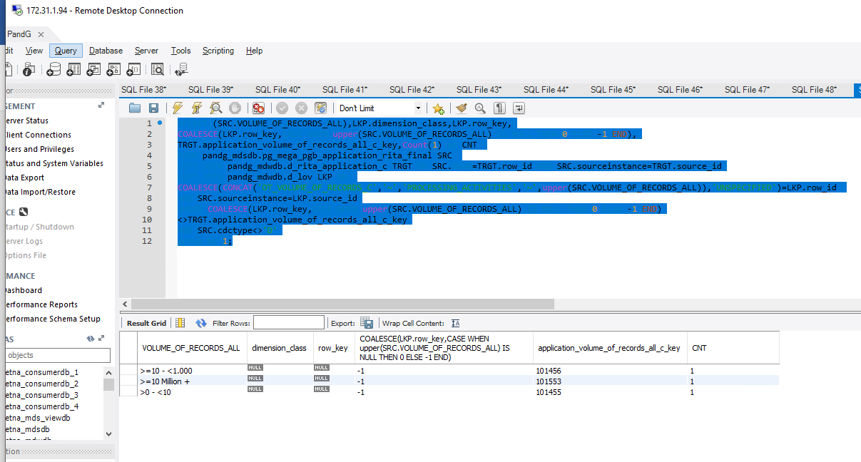

Issue 2:

SELECT SRC.le_name,COALESCE(SRC.le_name,'UNSPECIFIED'),TRGT.rita_app_legal_entity_name,Count(1) as CNT

FROM

(

SELECT NAME,sourceinstance,cdctype,GROUP_CONCAT(DISTINCT le_name ORDER BY le_name ) AS le_name FROM

(

SELECT a.NAME,a.sourceinstance,LEG.le_name,cdctype

FROM pandg_mdsdb.pg_mega_pgb_application_rita_final a

LEFT JOIN

(SELECT app_hexid,sourceinstance,le_hexid,le_name,count(1) FROM pandg_mdsdb.pg_mega_pgv_app_le_final

WHERE (le_hexid IS NOT NULL AND le_hexid<>'') AND (app_hexid IS NOT NULL AND cdctype<>'D')

GROUP BY 1,2,3,4) LEG ON a.NAME=LEG.app_hexid AND a.sourceinstance=LEG.sourceinstance

) X

GROUP BY NAME

) SRC

LEFT JOIN pandg_mdwdb.d_rita_application_c TRGT ON (SRC.NAME=TRGT.row_id AND SRC.sourceinstance=TRGT.source_id)

WHERE COALESCE(SRC.le_name,'UNSPECIFIED')<>TRGT.rita_app_legal_entity_name

AND SRC.cdctype<>'D'

group by 1;

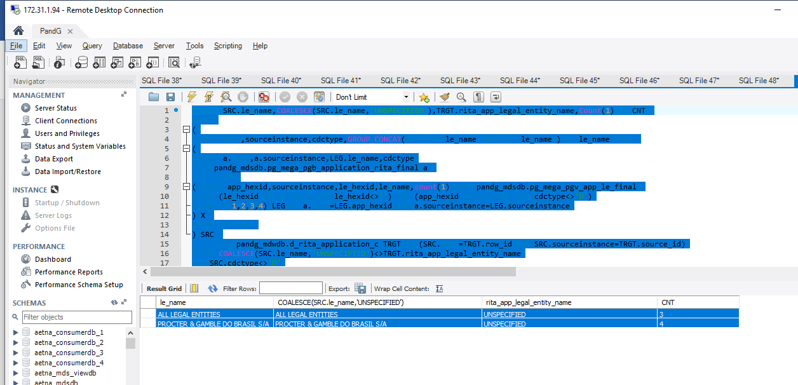

Issue 3:

SELECT COALESCE(SRC1.Organization_NAME,'UNSPECIFIED'),TRGT.rita_app_software_supplier_name,

Count(1) as CNT

FROM

(

SELECT SRC.NAME,SRC.sourceinstance,

GROUP_CONCAT(DISTINCT Organization ORDER BY Organization) AS Organization_NAME,

GROUP_CONCAT(DISTINCT CARDINAL_CODE ORDER BY Organization) AS CARDINAL_CODE

FROM pandg_mdsdb.pg_mega_pgb_application_rita_final SRC

LEFT JOIN

(SELECT a.app_hexid,a.responsible_org_unit_hexid,a.sourceinstance,Count(1)

FROM pandg_mdsdb.pg_mega_pgv_app_responsible_org_person_final a

WHERE (a.pg_software_supplier<>'N' AND a.pg_software_supplier IS NOT NULL AND a.pg_software_supplier<>' ' )

AND a.app_hexid IS NOT NULL AND a.responsible_org_unit_hexid IS NOT NULL

group by 1,2,3) ORG ON SRC.NAME=ORG.app_hexid AND SRC.sourceinstance=ORG.sourceinstance

LEFT JOIN

(SELECT distinct b.NAME,LEFT((CARDINAL),255) AS CARDINAL_CODE,GENERICLOCALNAME,sourceinstance,

LEFT(replace(replace(replace(GENERICLOCALNAME, '[0000000000000000]',''),CONCAT('- ',CARDINAL),''),CARDINAL,'') ,255) AS Organization

FROM pandg_mdsdb.pg_mega_pgb_org_unit_final b

WHERE (b.CARDINAL IS NOT NULL AND b.CARDINAL<>'')) SE_CODE ON ORG.responsible_org_unit_hexid=SE_CODE.NAME AND ORG.sourceinstance=SE_CODE.sourceinstance

AND SRC.cdctype<>'D'

GROUP BY SRC.NAME

) SRC1

LEFT JOIN

pandg_mdwdb.d_rita_application_c TRGT ON SRC1.NAME=TRGT.row_id AND SRC1.sourceinstance=TRGT.source_id

WHERE COALESCE(SRC1.Organization_NAME,'UNSPECIFIED')<>TRGT.rita_app_software_supplier_name

group by 1;

